**Bad behavior:**

I attempted to simulate two nodes created with scripting engine and corresponding UI. But, the FPGA loop containing the nodes did not progress past the first iteration. It was hanging on the second node. The second node’s Receive Loop was running infinitely. We observed that the number of times Cmd Received Valid and Output Valid went from true to false were equal. Both wires saw a rising edge twice. These lines are inputs and outputs to the DLU with 4 Wire Handshake.vi in the DLU Loop.

FPGA Test code

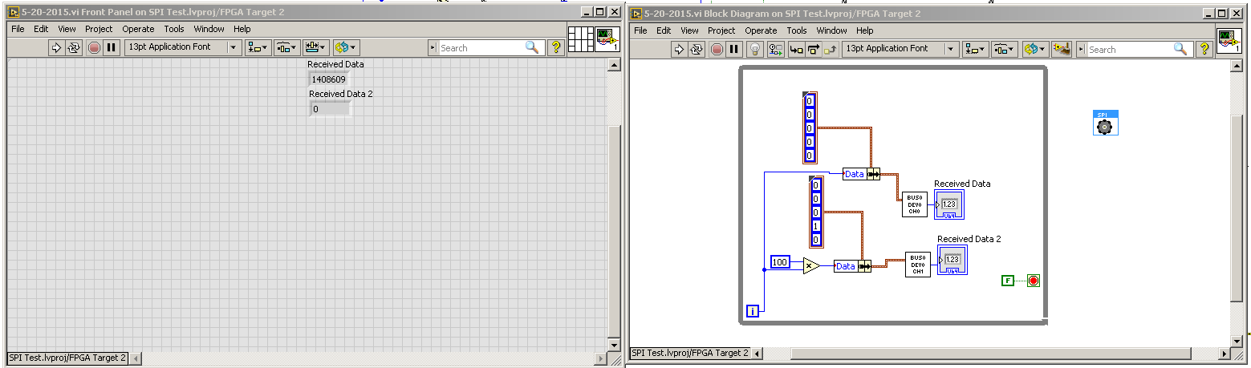

SPI Engine Block Diagram with counters for debugging

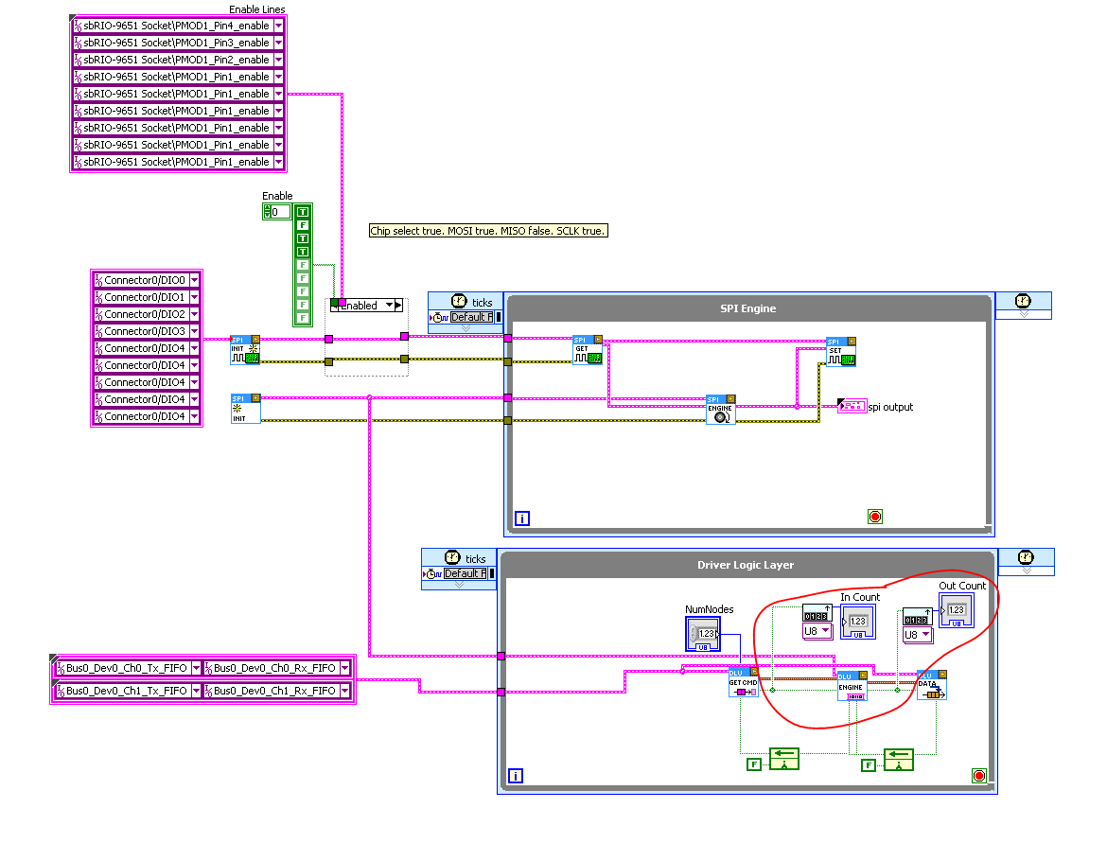

**Potential root cause:**

We believe this issue was being caused by incorrect wiring of a case selector terminal in the Enqueue Data to Nodes.vi of the DLU loop. Screenshots below.

Before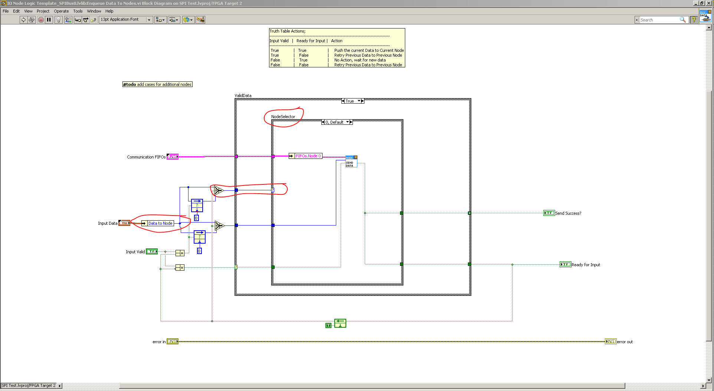

After

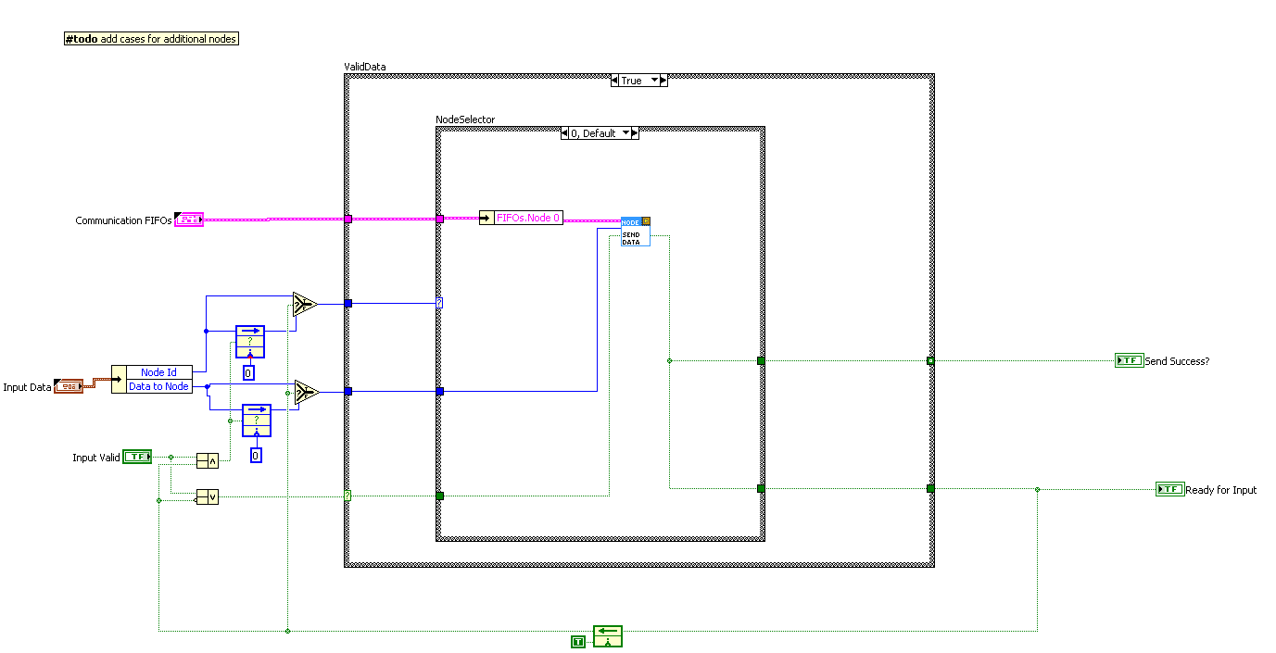

**Real root cause:**

We realized that root of the issue was actually a combination of the SPIEngine.SPICore.vi and the Read SPI Response for SPI Transactions.vi. The SPIEngine.SPICore.vi packages Chip Select ID into Node ID, where Node ID corresponds to channels on a chip or device. Instead, this should be packaged into Chip Select/Device ID or not sent at all.

SPIEngine.SPICore.vi 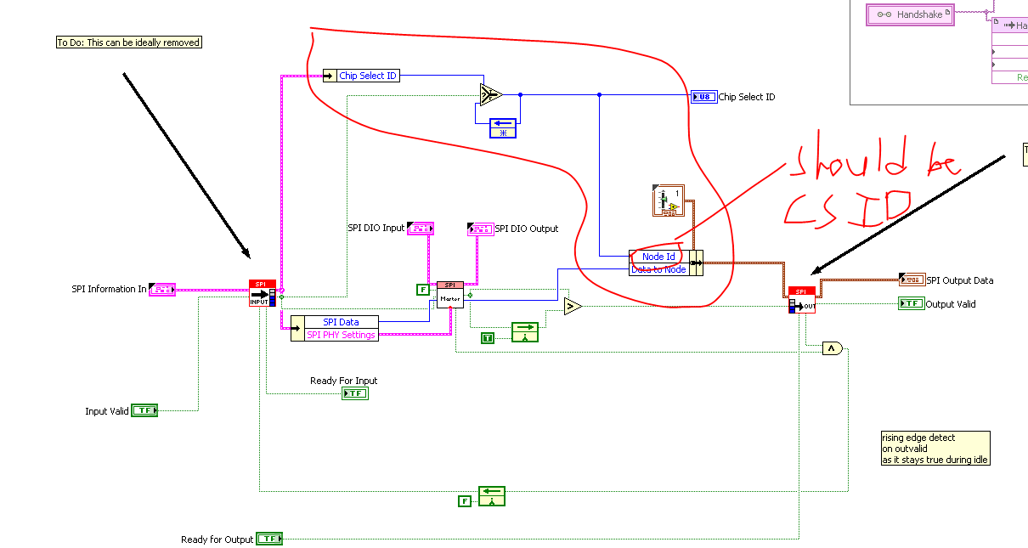

Similarly, the Read Data output Read SPI Response for SPI Transactions.vi should either be changed or reduced in size. The Node ID item should be named Chip Select/ Device ID or be removed. Kalyan stated that it should be removed and the output cluster should be replaced with an array for scalability. This will be beneficial when attempting to read multiple device channels in parallel. The Node ID output from the output cluster of the DLU should come from the Node ID stored in the effectively latched cluster at the top of the case structure.

Before

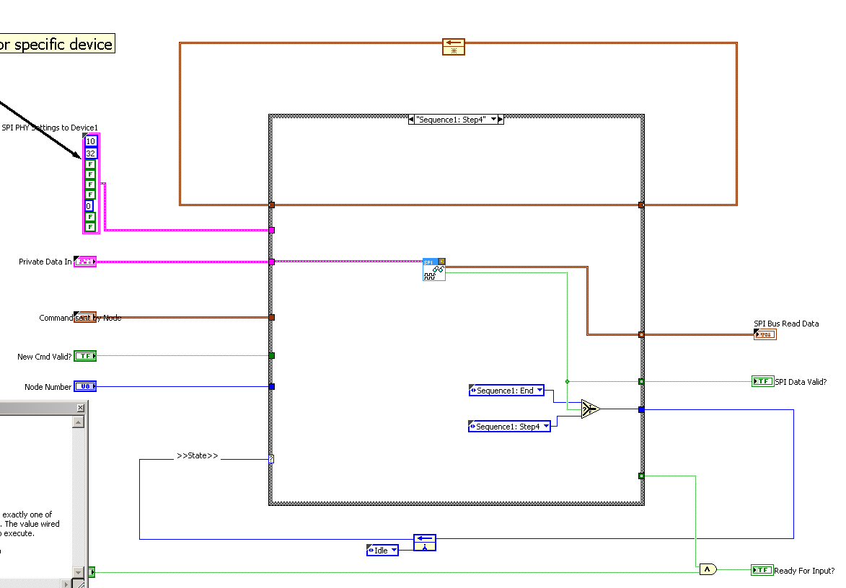

After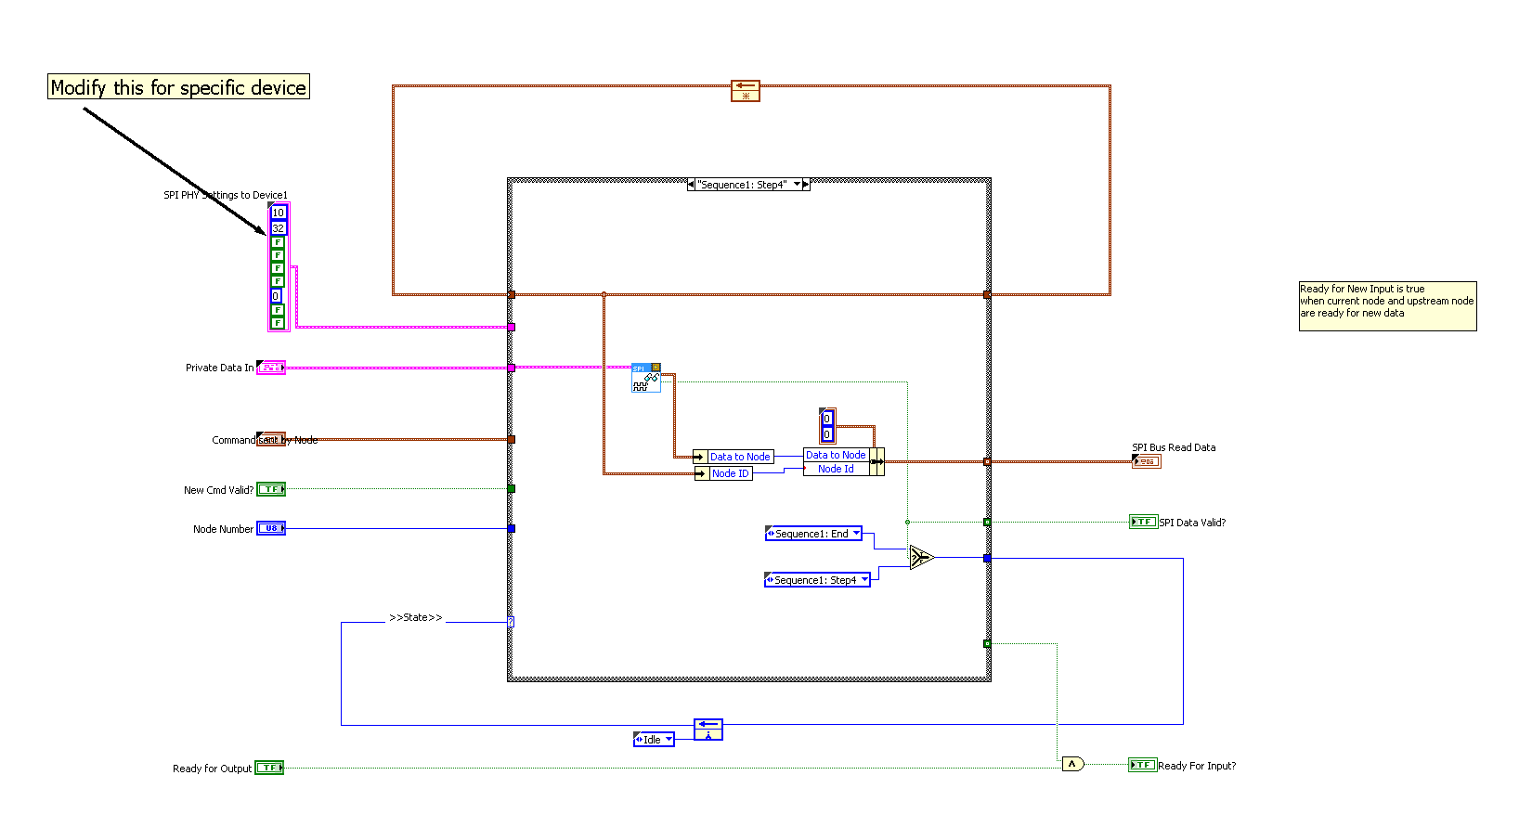

Steps to complete:

1. Scripting template fixes
   1. New DLU template
   2. Fix Enqueue data in DLU loop
2. SPI API
   1. Rename Node ID to Chip Select Select
   2. Remove Node ID from Read Data output cluster of the SPI Read function
      1. Convert output type to an array